**GEO2010 Spring 2017**

**Exercise 8**

Obligatory exercise 8 must be submitted by April 3, 2017.

**Training Exercise 8.1**

**This exercise concerns the contents of chapter 10 in Dingman.**

**Stream Order**

Stream orders describe the bifurcation (Norsk: “Forgrening”) of a river network. The order of a stream can be determined by following these steps (**See figure 10.1 on page 456 in Dingman.)**:

a. Give the smallest fingertip tributaries order 1.

b. Where two channels of order ***i*** join, a channel of order ***i*+1** result. For example, when two streams of order 1 join together, a stream of order 2 results. When two streams of order 2 join together, a stream of order 3 results.

c. Where a stream of lower order joins a stream of higher order, the stream downstream retains the higher of two orders.

1) Define drainage density (Norsk: “Dreneringstetthet”) of a watershed.

2) Determine the stream orders in the watershed in Figure 1

3) The stream network in Figure 1 covers an area of 365 km2 and contains 67 streams with a total length of 23 km. Calculate the drainage density and the stream density.

*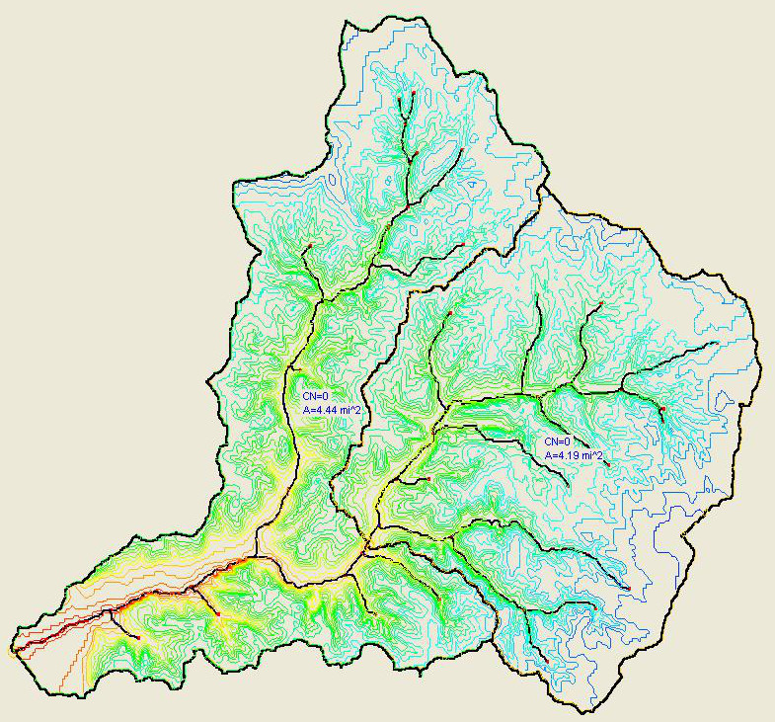Figure 1:*

**Obligatory Exercise 8**

1. A drainage basin is found to have the following data: Area of the basin = 2500 km2; Length of the main stream = 110 km, the perimeter of the basin = 367 km. Determine the form factor, circularity ratio, elongation ratio and the compactness coefficient for the basin. (se definitions below)

2. For an urban watershed, estimate and compare the time of concentration using the Kirpich (1940), Chow (1962) and NERC (1975) methods and comment on your results. (for formula please refer Dingman Table 10.8, page 513) [Given: Length of Main stream (L) = 110 km, Sine of channel slope angle (Sc) = 0.35)

**Shape of basin**

*The shape of the basin is quantitatively measured by various factors such as form factor, circulatory ratio, elongation ratio and compactness coefficient.*

*The form factor $F_{f}$ is defined as the ratio of the basin area to the square of the basin length. That is*

$$F_{f}=\frac{A}{L^{2}}$$

*Where, A is drainage basin area and L is drainage basin length.*

*Circulatory ratio $C_{r}$: It is a ratio of the drainage basin area $A$ to the area of the circle whose perimeter $p$ is equal to the perimeter of basin*

$$C_{r}=\frac{4πA}{p^{2}}$$

*Elongation ratio Er: It is a ratio of diameter of a circle whose area is same as the area of drainage basin to the length of the basin.*

$$E_{r}=\frac{D}{L}$$

*Er = D/L*

*Where, D is diameter of circle having area of drainage basin.*

*Compactness coefficient Cc: it is a ratio between perimeter of a drainage basin and perimeter of circle whose area is equal to the area of the area of drainage basin.*

$$C_{c}=\frac{p}{\sqrt{4πA}}$$